ASSIGNMENT-4

DISTANCE DETECTION USING ULTRASONIC SENSOR

|  |  |
| --- | --- |
| Date | 28 October 2022 |
| Team ID | PNT2022TMID43478 |
| Name | SNEHA M |
| Student Roll Number | 720319106022 |
| Maximum Marks | 2 Marks |

# **Question1 :**

Write code and connections in wokwi for ultrasonic sensor. Whenever distance is less than 100 cms send "alert" to ibm cloud and display in device recent events.

WOKWI LINK :

https://wokwi.com/projects/305566932847821378

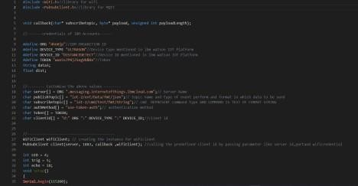CODE :

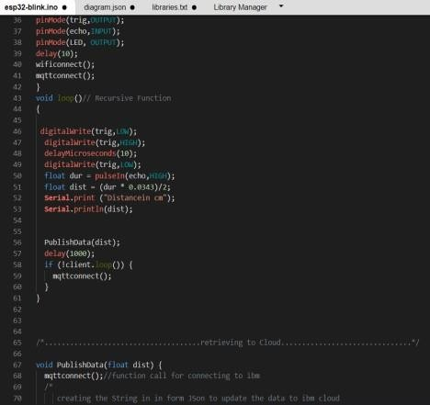

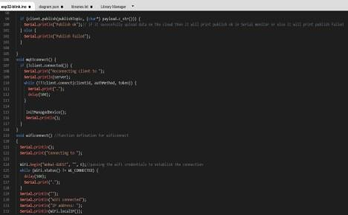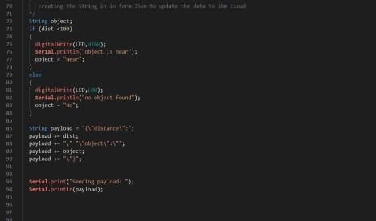

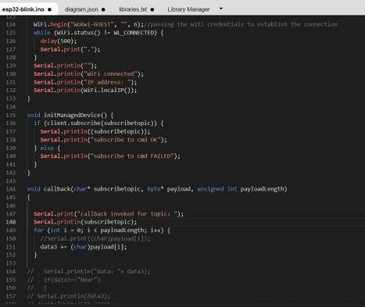

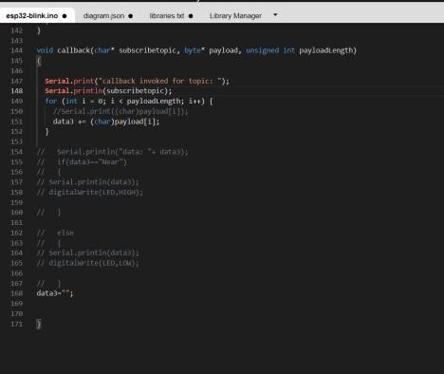

# OUTPUT:

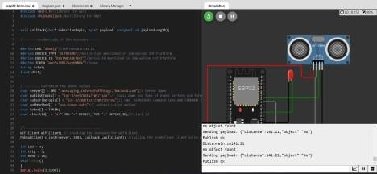

Data send to the IBM cloud device when the object is far

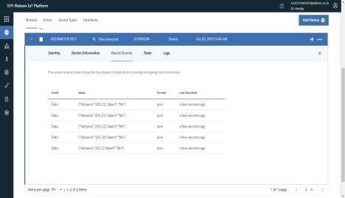

# when object is near to the ultrasonic sensor

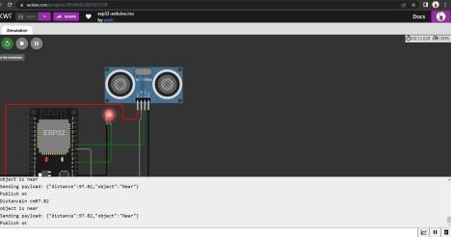

Data sent to the IBM Cloud Device when the object is near

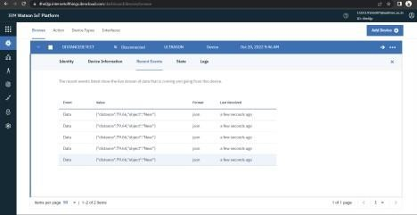

# https://wokwi.com/projects/305566932847821378